SCHUYLKILL COUNTY DEMOCRATIC COMMITTEE
610 West Market Street ● P.O. Box 66 ● Pottsville, PA 17901 ● 570-622-3155

June 7, 2023

Dear fellow Democrat,

Hi, and welcome as a recently registered Democrat in Schuylkill County. My name is Todd Zimmerman, and I am the new Chairman of the Schuylkill County Democratic Committee. I see that you are 18 years old. If you are still in High School, would you be willing to be a “Democratic Ambassador” in your school district? If so, send me an email to toddpzimmerman@yahoo.com I have enclosed a registration card with a QR code. Please use it to register friends and acquaintances. In fact, you can pre-register a 17 year-old if they are turning 18 on or before election day, Tuesday, November 7th.

Everyone has their own “why” as to why they joined the Democratic Party – women’s reproductive rights, livable blue-collar wages, clean environment through alternative energy, civil rights and equality for all, etc. If interested, we would like you to become more involved with our party and there are plenty of opportunities.

We are seeking local volunteers in your current voting precinct. For those of you that have a Facebook account, we have developed the Schuylkill Democratic Action Group. This is a private group and we screen to make sure that only Democrats that live within Schuylkill County are members. Other FB groups include, Young Democrats, Schuylkill County Democratic Women’s League, and Eastern Schuylkill Democratic Club. For more information on regional and Democratic friendly clubs, please visit, https://schuylkilldems.com.

2023 is a major election year. Each borough/township will be having their own municipal races. We need people to run for school board, borough council, township supervisors. Please visit our website to see all the listed local races. We also need to elect two Democratic County Commissioners to change the direction of Schuylkill County. At the State level, we are selecting four judicial candidates. Elections matter. We need to keep the Democrats in control of the PA Supreme Court, and gain the majority in the Superior and Commonwealth Courts.

If you would like to be on our email list to find out about upcoming events, please reach out to me at toddpzimmerman@yahoo.com. Thank you again for joining the Democratic Party. I hope to hear from you.
Sincerely,

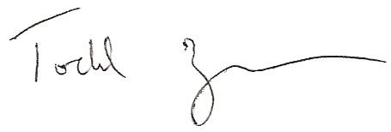
Todd Zimmerman
Chairman, SCDC

